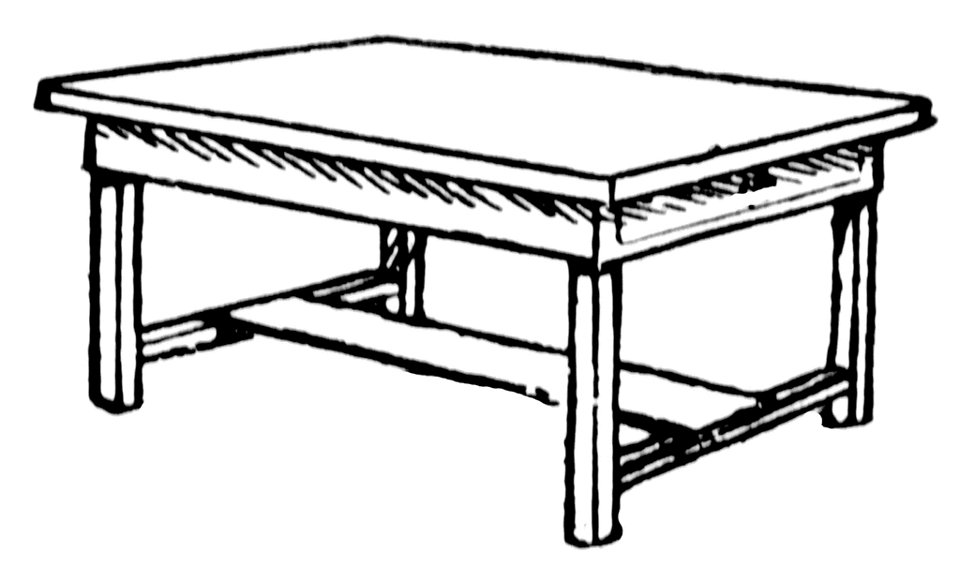**Creating a Table Word**

Laying out information in a table makes it easier to read and understand.

Skills: making tables, merging cells, splitting cells, cell shading, and cell align

|  |  |  |  |  |  |  |  |  |
| --- | --- | --- | --- | --- | --- | --- | --- | --- |
|  |  |  |  |  |  |  |  |  |
|  |  |  |  |
|  |  |  |  |
|  | |  | | | |  |  |  |

1. Open Word – Open a NEW BLANK Document – Save AS Tables Exercise

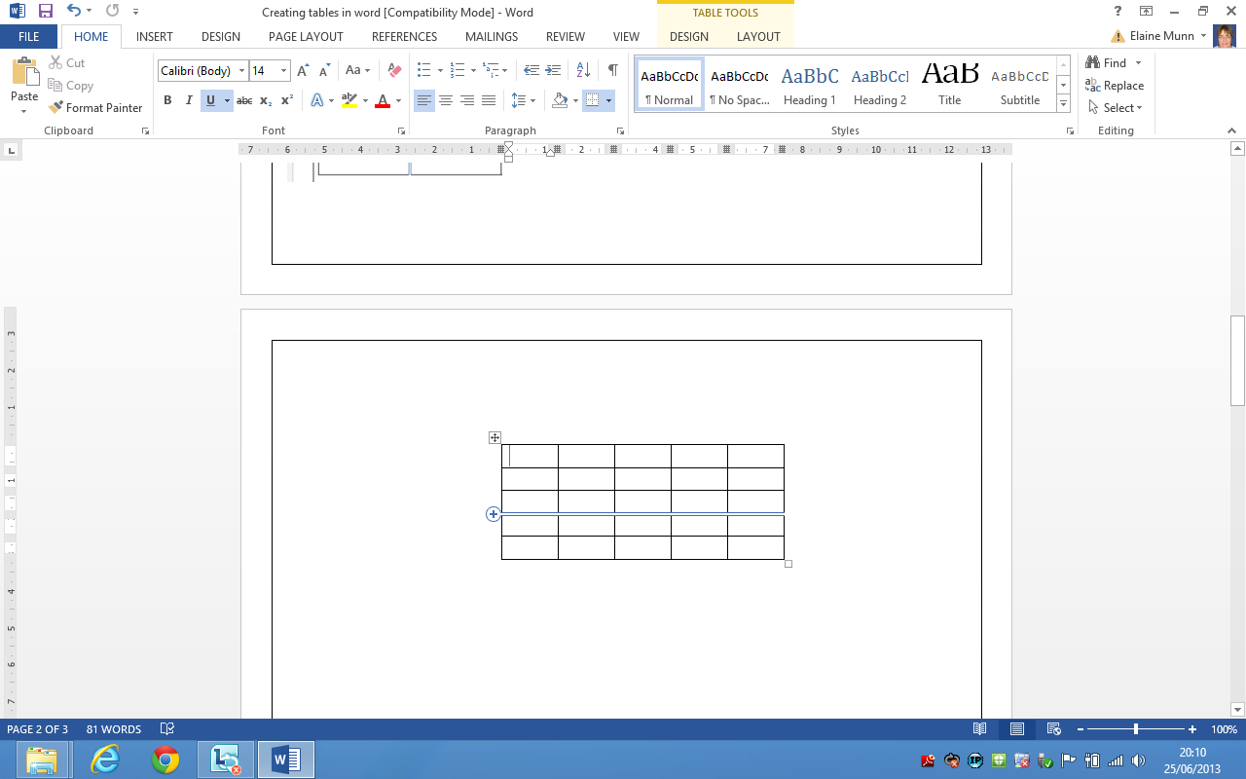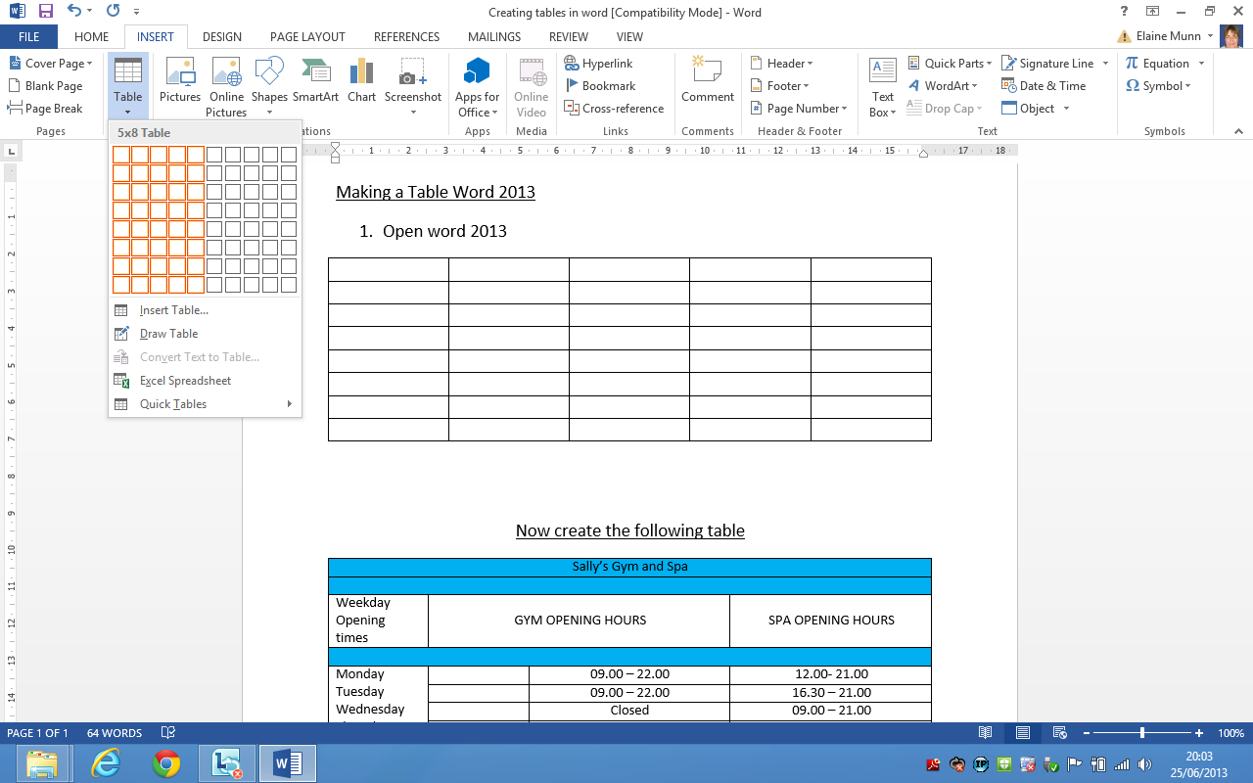

INSERT RIBBON > TABLE > 5 columns x 8 Rows

**OR**

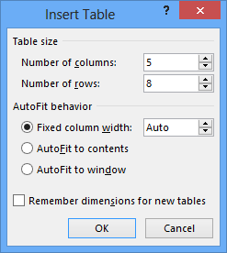Insert > Table > Insert Table

Clicking on the + at row or column ends allows the user to add a new row or a new column

Now create the following table

|  |  |  |  |  |
| --- | --- | --- | --- | --- |
| Sally’s Gym and Spa | | | | |
|  | | | | |
| Weekday  Opening  times | GYM OPENING HOURS | | SPA OPENING HOURS | |
|  | | | | |
| Monday  Tuesday  Wednesday  Thursday  Friday |  | 09.00 – 22.00 | 12.00- 21.00 | |
|  | 09.00 – 22.00 | 16.30 – 21.00 | |
|  | Closed | 09.00 – 21.00 | |
|  | 09.00 – 22.00 | 16.30 – 21.00 | |
|  | 09.00 – 22.00 | 12.00 – 21.00 | |
|  | | | | |
| Weekend  Opening Times | | |  |  |
| Saturday |  | 09.00 – 20.00 | 09.00 – 16.30 | |
| Sunday |  | 09.00 – 20.00 | 12.00 – 16.30 | |

* Does it look the same?
* Make a border around the page.
* Insert a clip art image related to gym or spa.
* Insert your name and today’s date into footer.
* Send it as an attachment to: **elaine.munn@aol.com**